**Exercise 1: Setting Up JUnit**

**Scenario:**

You need to set up JUnit in your Java project to start writing unit tests.

Steps:

1. Create a new Java project in your IDE (e.g., IntelliJ IDEA, Eclipse).

2. Add JUnit dependency to your project. If you are using Maven, add the following to your pom.xml:

junit junit 4.13.2 test

3. Create a new test class in your project.

**ANSWER:**

**1. pom.xml (Maven dependency setup)**

<project xmlns="http://maven.apache.org/POM/4.0.0"

xmlns:xsi="http://www.w3.org/2001/XMLSchema-instance"

xsi:schemaLocation="http://maven.apache.org/POM/4.0.0

http://maven.apache.org/xsd/maven-4.0.0.xsd">

<modelVersion>4.0.0</modelVersion>

<groupId>org.example</groupId>

<artifactId>JUnitDem</artifactId>

<version>1.0-SNAPSHOT</version>

<dependencies>

<dependency>

<groupId>junit</groupId>

<artifactId>junit</artifactId>

<version>4.13.2</version>

<scope>test</scope>

</dependency>

</dependencies>

</project>

**2. Calculator.java**

package org.example;

public class Calculator {

public int add(int a, int b) {

return a + b;

}

}

**3.** **CalculatorTest.java**

package org.example;

import org.junit.Test;

import static org.junit.Assert.*;

public class CalculatorTest {

@Test

public void testAdd() {

Calculator calc = new Calculator();

int result = calc.add(2, 3);

assertEquals(5, result);

}

}

**Output:**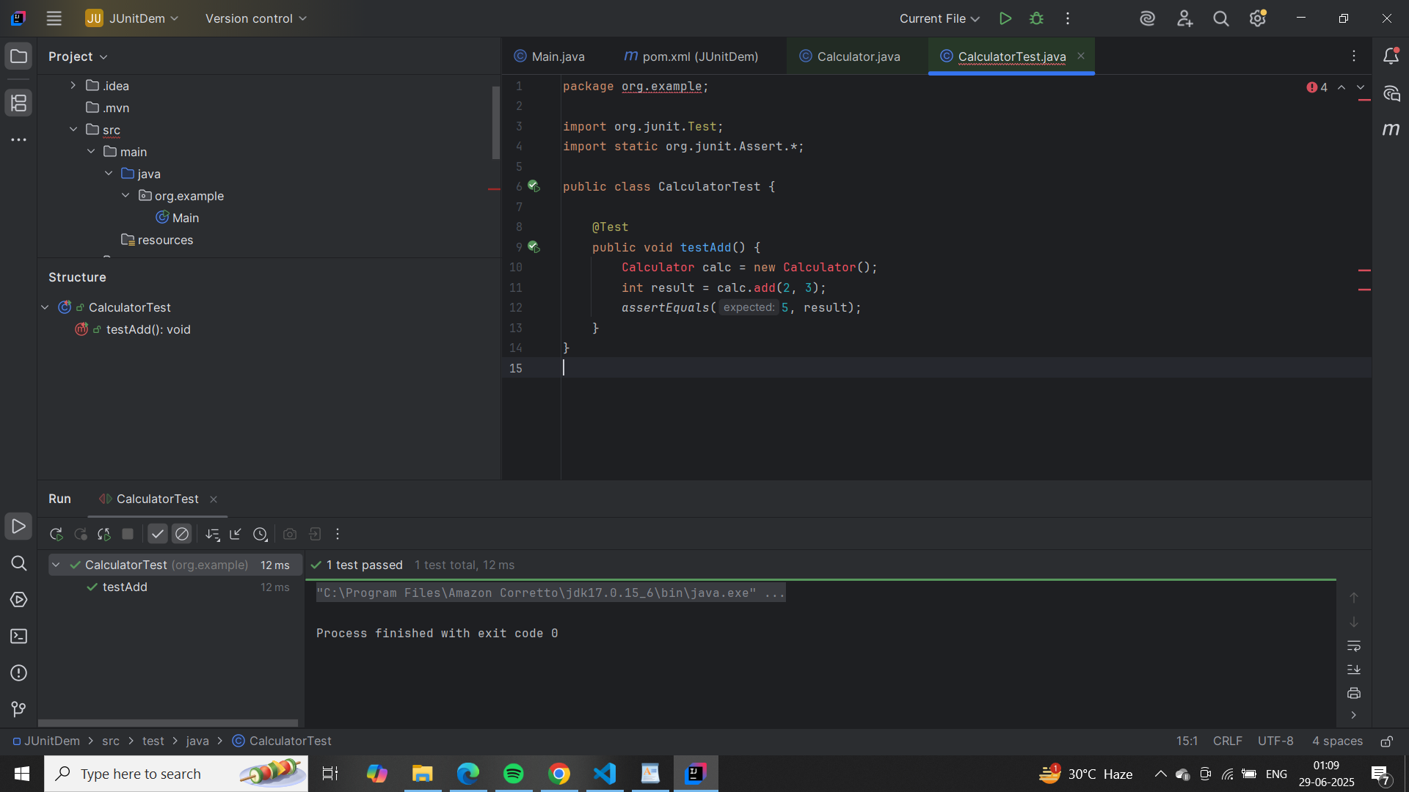

**Exercise 3: Assertions in JUnit**

**Scenario:**

You need to use different assertions in JUnit to validate your test results.

Steps:

1. Write tests using various JUnit assertions.

Solution Code:

public class AssertionsTest {

@Test

public void testAssertions() {

// Assert equals

assertEquals(5, 2 + 3);

// Assert true

assertTrue(5 > 3);

// Assert false

assertFalse(5 < 3);

// Assert null

assertNull(null);

// Assert not null

assertNotNull(new Object());

}

}

**Answer:**

**Pom.xml**

<project xmlns="http://maven.apache.org/POM/4.0.0"

xmlns:xsi="http://www.w3.org/2001/XMLSchema-instance"

xsi:schemaLocation="http://maven.apache.org/POM/4.0.0

http://maven.apache.org/xsd/maven-4.0.0.xsd">

<modelVersion>4.0.0</modelVersion>

<groupId>org.example</groupId>

<artifactId>JUnitAssertionsDemo</artifactId>

<version>1.0-SNAPSHOT</version>

<dependencies>

<dependency>

<groupId>junit</groupId>

<artifactId>junit</artifactId>

<version>4.13.2</version>

<scope>test</scope>

</dependency>

</dependencies>

</project>

**AssertionsTest.java**

package org.example;

import org.junit.Test;

import static org.junit.Assert.*;

public class AssertionsTest {

@Test

public void testAssertions() {

// Assert equals

assertEquals(5, 2 + 3);

// Assert true

assertTrue(5 > 3);

// Assert false

assertFalse(5 < 3);

// Assert null

assertNull(null);

// Assert not null

assertNotNull(new Object());

}

}

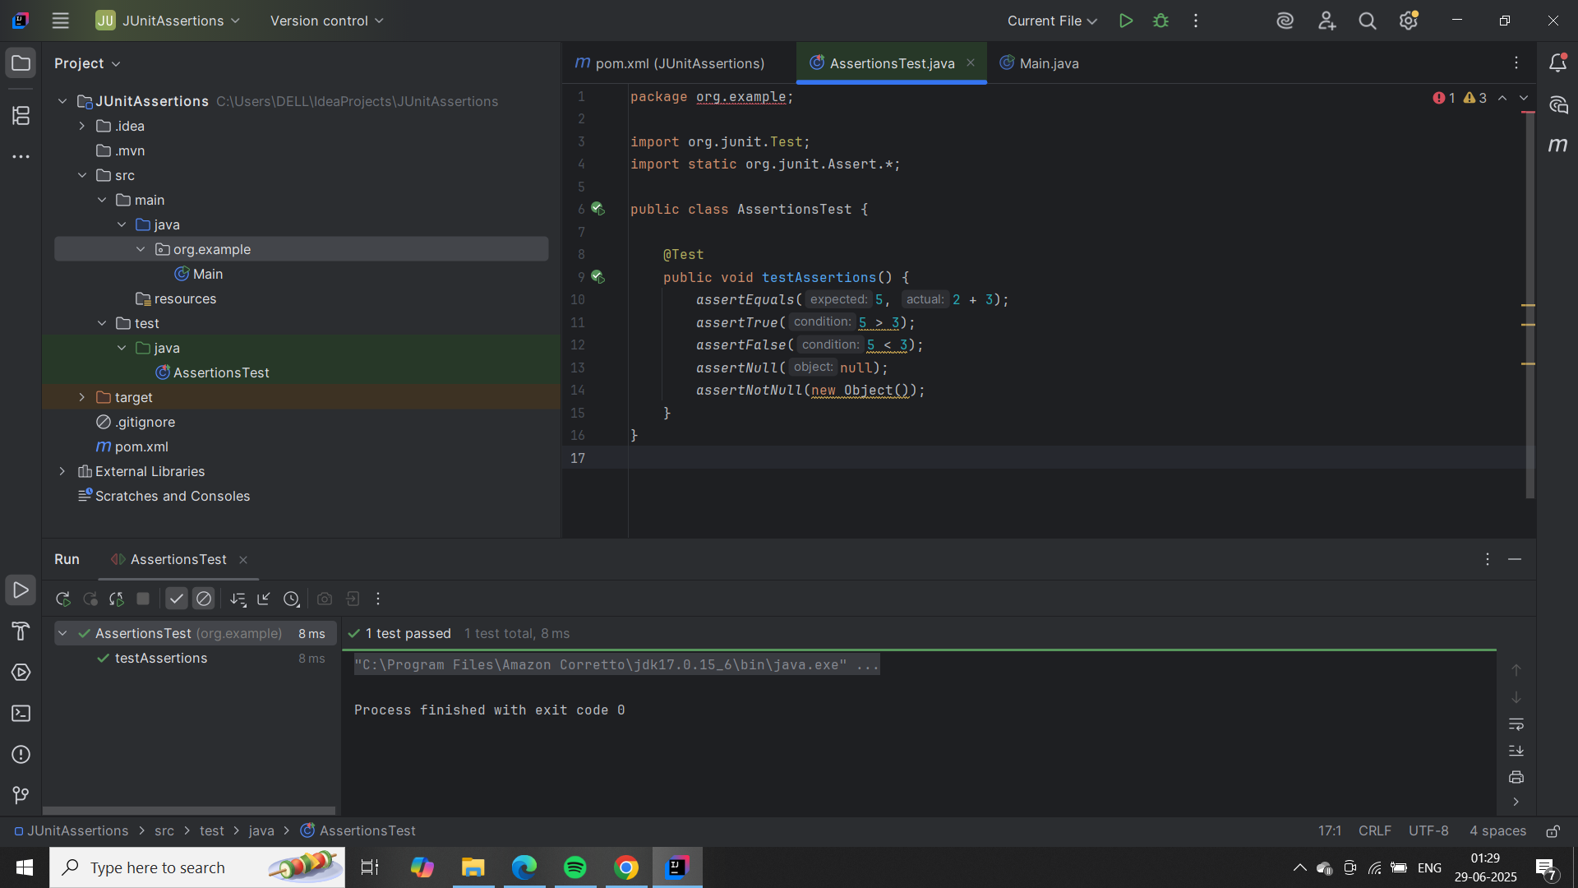

**Exercise 4: Arrange-Act-Assert (AAA) Pattern, Test Fixtures, Setup and Teardown Methods in JUnit**

**Scenario:**

You need to organize your tests using the Arrange-Act-Assert (AAA) pattern and use setup and teardown methods.

Steps:

1. Write tests using the AAA pattern.

2. Use @Before and @After annotations for setup and teardown methods.

**Answer:**

**Pom.xml**

<project xmlns="http://maven.apache.org/POM/4.0.0"

xmlns:xsi="http://www.w3.org/2001/XMLSchema-instance"

xsi:schemaLocation="http://maven.apache.org/POM/4.0.0

http://maven.apache.org/xsd/maven-4.0.0.xsd">

<modelVersion>4.0.0</modelVersion>

<groupId>org.example</groupId>

<artifactId>JUnitAAAPattern</artifactId>

<version>1.0-SNAPSHOT</version>

<dependencies>

<dependency>

<groupId>junit</groupId>

<artifactId>junit</artifactId>

<version>4.13.2</version>

<scope>test</scope>

</dependency>

</dependencies>

</project>

**1. Calculator.java**

package org.example;

public class Calculator {

public int add(int a, int b) {

return a + b;

}

}

**2. CalculatorTest.java**

package org.example;

import org.junit.After;

import org.junit.Before;

import org.junit.Test;

import static org.junit.Assert.*;

public class CalculatorTest {

private Calculator calculator;

@Before

public void setUp() {

// Arrange: setup before each test

calculator = new Calculator();

System.out.println("Setup: Calculator created");

}

@After

public void tearDown() {

// Cleanup after each test

System.out.println("Teardown: Test finished");

}

@Test

public void testAdd() {

// Act

int result = calculator.add(3, 2);

// Assert

assertEquals(5, result);

}

}

**Output:**

